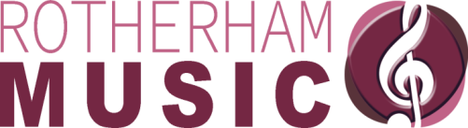
Dear Parent/Carer,

Children have had a demonstration by musicians from Rotherham Music and we are pleased to be able to offer this exciting opportunity to those who have expressed an interest to learn an instrument.

Lessons will be held weekly, in groups, from as little as £5 per week (depending on numbers/instrument choice). If there are sufficient numbers to make a group (3 or more pupils on same instrument), the cost is £55 per pupil per term; if the numbers are not sufficient for a group, we can offer a shared lesson (2 pupils) for £95.20 per pupil per term.

Instrument hire is free for the first year and £10 per year thereafter.

Please indicate, in the boxes below, your child’s 1st and 2nd choice of instrument and return to school. (We will make every effort to accommodate your child’s 1st choice instrument).
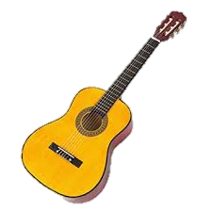
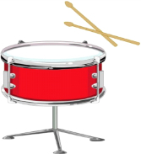
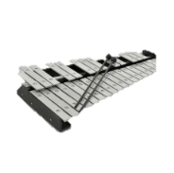
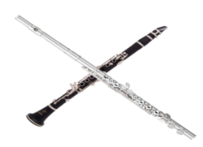
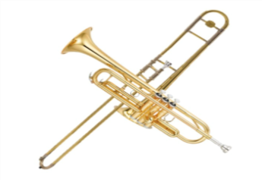
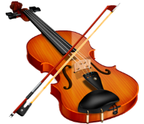

Clarinet or Flute Violin or Cello Guitar Trumpet or Trombone Drums/Percussion

I understand the lesson cost structure and that if a group lesson is not available, I may be offered a shared (2 pupil) lesson.

Student Name

Age/ Year Group

School

Parent Name
(Please Print)
Parent Email Address

Parent Signature

Date

Please complete and return the form to your school office.

